

##### Question/Answer Booklet

Name: Marking KEY

PHYSICAL EDUCATION STUDIES

**PES11Gen Marks Test 3 Functional Anatomy and Biomechanics**

Working time for paper: 45 mins

###### *To be provided by the candidate*

Standard items: pens, pencils, eraser, correction fluid, ruler, highlighter

|  |  |  |
| --- | --- | --- |
| Topics | Number of Questions | Marks |
| Biomechanics | 6 | 25 |
| Functional Anatomy | 5 | 35 |
| Total Marks |  | 60 |

**Answer all questions on the question paper**

1. **Biomechanics** is the science concerned with the Internal and **external forces** acting on a human body or an object and the EFFECTS/RESULTS/MOVEMENT produced by these **forces**. (2)
2. The study of Biomechanics assists with improving performances or results. Describe 3 themes or categories of biomechanics that a coach would use. (3)
3. modify techniques
4. appropriate equipment
5. used to prevent injury
6. The study of Biomechanics involves 3 types of motion. Name all 3 and explain the difference between each. (6)
7. Linear (translation) whole body moves the same distance at the same time in the same direction.
8. Angular: This motion occurs when the body moves around an axis of rotation
9. combines angular and linear motion.
10. When you apply a force to an object or body, in a biomechanical sense, what four things can happen to it? (4)

slowed, accelerated, stopped or have its direction changed

1. The forces come from two sources, one of them is external forces.
2. Name 3 external forces? Gravity and friction (air, water, ground) (3)
3. Give an example of a sporting activity where each of these external forces can be found? Water- Swimming, gravity- skydiving, gravity - shotput, ground friction - sprinting, ground friction - motor racing (grip), air friction - cycling (3)
4. When applying a force to an object, there are two main things to consider. Complete the following sentences so that they make sense in relation to how we apply force and the effect forces have on an object. (4)

The GREATER the applied force the greater the ACCELERATION (or change in speed in a given direction)

b) The greater the MASS the greater the force needed to MOVE the object.

1. Provide labels for the muscles/muscle groups numbered in the diagram below. (11)

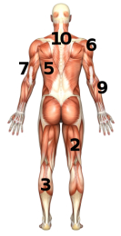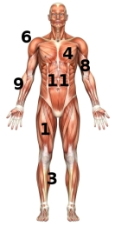

1 quadriceps 2 Hamstrings

3 gastrocnemius 4 Pectoralis Mj

5 Latisimus Dorsi 6 Deltoid

7 Triceps Brachi 8 Biceps Brachi

9 Forearm 10 Trapezius

11 abdominal group

8a) What does the term “antagonistic pairs of muscle” mean? (2)

Muscles that work in opposites, one extends and the other flexes

b) Provide an example of an antagonistic pair of muscle. (1)

Biceps and triceps

9) Study the diagrams below and provide labels for letter A-J (10)

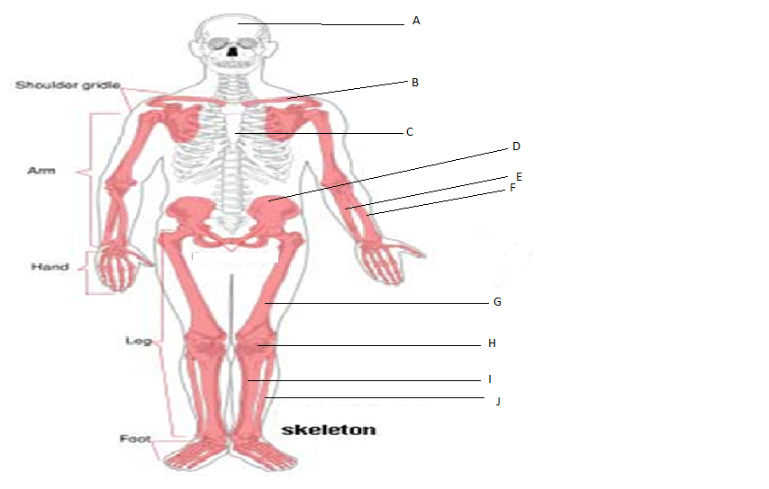

A Skull or cranium B clavicle

C Sternum D Pelvis

E ulna F radius

G femur H patela

I tibia J fibula

10) Provide definitions/explanations of the following terminology.

1. Tidal Volume: air inspired and expired with normal breathing (2)
2. Vein: vessel that transports de-oxygenated blood to the heart (2)
3. Pulmonary circulation: the flow of blood from the heart to the lungs and back to the heart (2)
4. Blood vessel: are vessels carrying blood to and from the heart. (2)

10) What is the primary function of the Cardiorespiratory System? (2)

To supply cells with O2 and remove waste to maintain normal cellular function throughout the whole body.

11) How can monitoring your pulse during and after exercise be an indicator of your fitness level? (2)

The quicker your HR recovers to normal (resting HR) the fitter you are as it indicates your heart can cope easier with the load compared to someones HR that stays high for a long time after exercising.